ДЕМОНСТРАЦИОННАЯ ВЕРСИЯ
ПРОМЕЖУТОЧНОЙ АТТЕСТАЦИИ В 11 КЛАСЕ (углубление 2)

Part 1. Listening Comprehension

You will hear a telephone call between a customer and a sales person. Answer the questions (1-7) by choosing the option from the list (a, b or c). You will hear the recording twice.

- Why doesn’t the customer know the exact price of the monitor he wants to buy?
- he hasn’t got a new catalogue
- he has no catalogue
- the catalogue doesn’t include the monitor in question
- How can “Computer System” help in solving the problem of the customer’s printer?
- by repairing it
- by setting it up
- by selling him a new one
- Why doesn’t the customer want to buy a laser printer?
- laser printers are not reliable
- he doesn’t like their design
- they are too expensive
- What is the price of the printer the customer decides to order?
- 150 pounds
- 180 pounds
- 600 pounds
- Why does the customer need a mouse for his computer?
- he hasn’t got one
- the one he has got is broken
- the one he has got doesn’t work well
- When is the customer going to order some software?
- when he gets a new catalogue
- right on the spot
- when he saves enough money
- How much does the customer have to pay for delivery?
- 150 pounds
- a small sum
- nothing

Question | 1 | 2 | 3 | 4 | 5 | 6 | 7
Answer

Part 2. Reading Comprehension

Until recently graffiti was considered to be an example of young people rebellion.
Read the passage from an article about graffiti. For questions 1-6, choose the best answer from the suggested.
New Yorkers used to see the graffiti on the walls of poor neighbourhoods and subway trains as an example of young people rebellion. The slogans were seen as aggressive, the work of vandals seeking to express their identities or even make a political point. Up to the 1970s most New Yorkers hated graffiti.
Since those days, graffiti has changed a lot and it is no longer found only in the subway and in the poor areas of the city. Nowadays, it has the status of “street art” and you get graffiti in places where you would not expect to – in advertisements, on clothes, on toys, and even on the Wall Street Journal’s official website! In the early 1980s, there was a real craze for graffiti art in its galleries. The trend was short-lived – until the arrival of hip-hop music in the 80s.
In her book, Subway Art, Martha Cooper says, “Graffiti came back with hip-hop music and people are now appreciating it for its style, which they couldn’t back then, because they couldn’t get beyond the vandalism thing”. Hip-hop was originally black music, sung by young African Americans from the poor, run-down districts of American cities. When it suddenly got to the top of the American music charts, hip-hop culture was spread, bringing graffiti with it.
Today companies are starting to use the appeal of graffiti in advertising. Kel Rodriguez, who used to spray New York subway trains, was the artist chosen to design the Wall Street Journal’s website and it is obviously done in graffiti style.
Many of this new wave of artists give lectures on developments in the art. Lee Quinones is having a lot of success in Europe and feels that European galleries and museums are open to his art form. “They want to support an artist as he develops,” comments Quinones, who can get up to $ 10,000 for his paintings. Indeed, the Groninger Museum in Holland is one of the few museums in the world that displays and recognizes graffiti as an art form.
Another artist, Blade, has his own website devoted only to the world of graffiti. This website has “a page” where Blade sells things with his own original designs all over the world – everything from baseball caps to yo-yos! Leonard McGurr, a street artist for 25 years, went from painting subway trains to designing and marketing graffiti-inspired clothes for young people. “Graffiti has been a story of survival”, he says. “There’s a way to benefit from your work without spoiling public property”.

- According to the article, people did not like graffiti because …
- nobody understood it.
- it made cities ugly.
- it considered to be the work of hooligans.
- Nowadays people’s attitude towards graffiti is …
- not as bad as it used to be.
- worse than before.
- the same as in the past.
- What do graffiti and hip-hop have in common according to the article?
- They are both illegal.
- They are both examples of political views.
- The came from similar background.
- What is said in the article about graffiti artists?
- Most of them moved to Europe.
- Some of them are treated as respected artists.
- They haven’t learnt how to draw properly.
- Lee Quinones thinks that graffiti is more popular in Europe because …
- graffiti artists can make money more easily there.
- graffiti is taken more seriously there.
- European museums and galleries have more space for graffiti as an art form.
- Some graffiti artists make money by …
- painting subway trains.
- selling painted street walls.
- selling products with graffiti design on them.

Question | 1 | 2 | 3 | 4 | 5 | 6
Answer

Part 3. Use of English
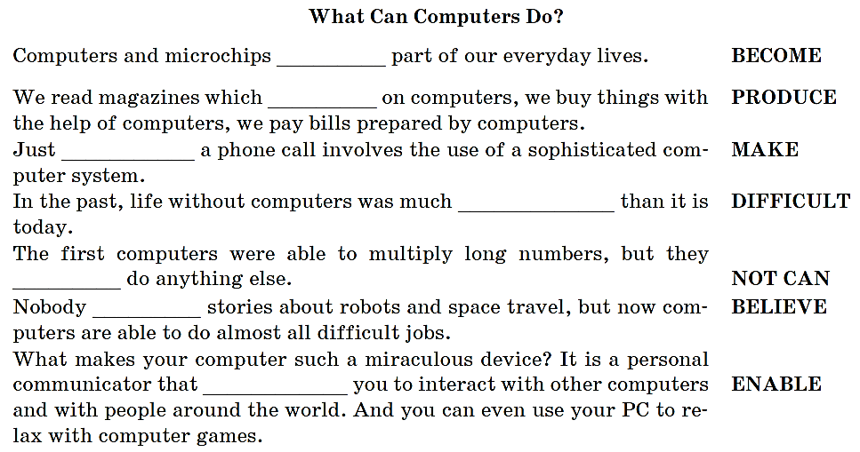
- Put the words in CAPITALS in the correct form to fill in the gaps.

- Use the words in CAPITALS to form new words to fill in the gaps.

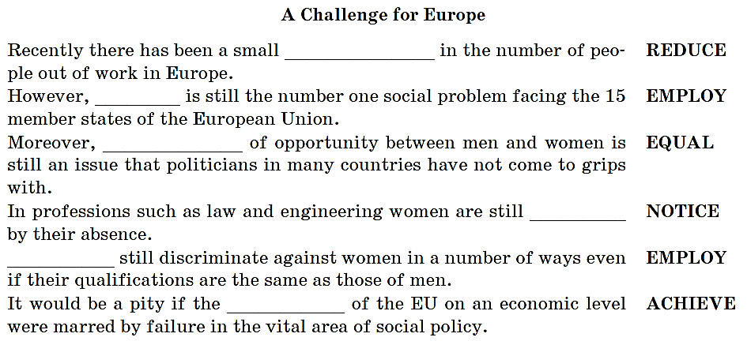

- Choose the best answer (a, b, c, d) to fill in the gaps I the text.
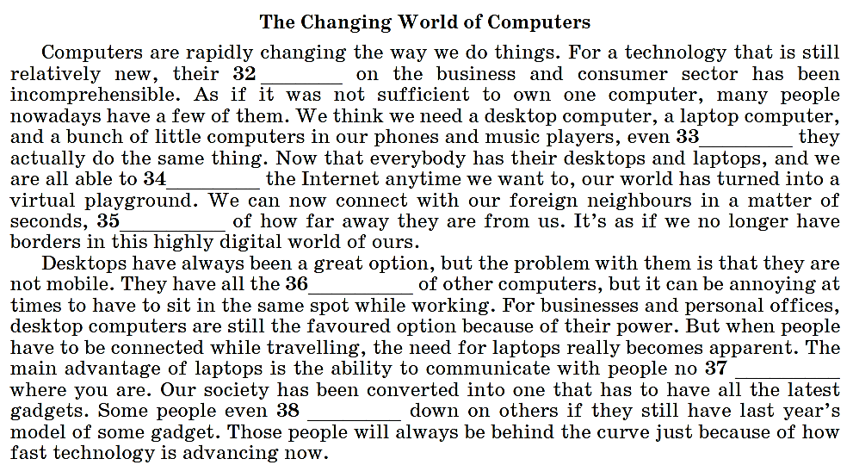

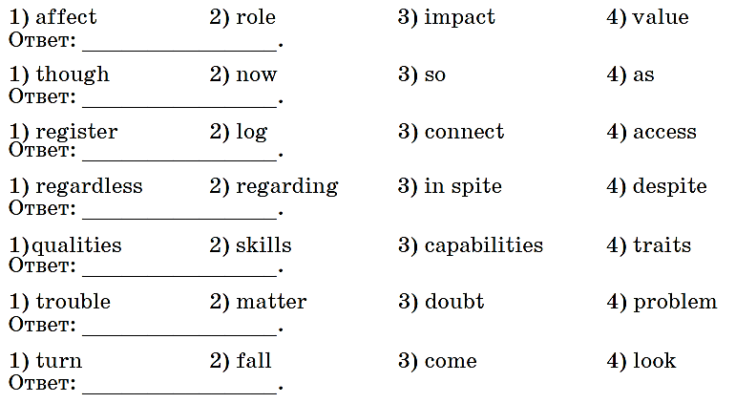

Part 4. Writing

Comment on the following statement.
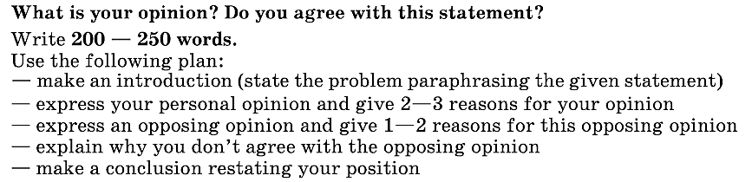
“A city life is really harmful”

